

Requirement & Design Specification

**ART ACADEMY (ADEMY)**

**Version: 1.0**

– Hanoi, August 2022 –

# *A - Added M - Modified D - Deleted

Contents

Record of Changes 2

I. Overview 4

1. User Requirements 4

1.1 Actors 4

1.2 Use Cases 4

2. Overall Functionalities 5

2.1 Screens Flow 5

2.2 Screen Descriptions 5

2.3 Screen Authorization 5

2.4 Non-UI Functions 6

3. System High Level Design 6

3.1 Database Design 6

3.2 Code Packages 7

II. Requirement Specifications 8

[1. <<Feature Name>> 8](https://docs.google.com/document/d/1N9Be_5Rrja1Eqz0p28IbpcJczygAp0N5ABD9v-qy_qU/edit?fbclid=IwAR1i495xbfs6ubse4rB1mlc5Foi8JxZpEGw5D52X6wEILqGj9pT_gEChnS0#heading=h.44sinio)

[1.1 <<UseCaseCode_UC Name>> 8](https://docs.google.com/document/d/1N9Be_5Rrja1Eqz0p28IbpcJczygAp0N5ABD9v-qy_qU/edit?fbclid=IwAR1i495xbfs6ubse4rB1mlc5Foi8JxZpEGw5D52X6wEILqGj9pT_gEChnS0#heading=h.2jxsxqh)

[2. Common Functions 11](https://docs.google.com/document/d/1N9Be_5Rrja1Eqz0p28IbpcJczygAp0N5ABD9v-qy_qU/edit?fbclid=IwAR1i495xbfs6ubse4rB1mlc5Foi8JxZpEGw5D52X6wEILqGj9pT_gEChnS0#heading=h.z337ya)

[2.1 UC-2_Login System 11](https://docs.google.com/document/d/1N9Be_5Rrja1Eqz0p28IbpcJczygAp0N5ABD9v-qy_qU/edit?fbclid=IwAR1i495xbfs6ubse4rB1mlc5Foi8JxZpEGw5D52X6wEILqGj9pT_gEChnS0#heading=h.3j2qqm3)

[3. Patron Feature 12](https://docs.google.com/document/d/1N9Be_5Rrja1Eqz0p28IbpcJczygAp0N5ABD9v-qy_qU/edit?fbclid=IwAR1i495xbfs6ubse4rB1mlc5Foi8JxZpEGw5D52X6wEILqGj9pT_gEChnS0#heading=h.1y810tw)

[3.1 UC-5_Order a Meal 12](https://docs.google.com/document/d/1N9Be_5Rrja1Eqz0p28IbpcJczygAp0N5ABD9v-qy_qU/edit?fbclid=IwAR1i495xbfs6ubse4rB1mlc5Foi8JxZpEGw5D52X6wEILqGj9pT_gEChnS0#heading=h.4i7ojhp)

[3.2 UC-6_Register for Payroll Deduction 13](https://docs.google.com/document/d/1N9Be_5Rrja1Eqz0p28IbpcJczygAp0N5ABD9v-qy_qU/edit?fbclid=IwAR1i495xbfs6ubse4rB1mlc5Foi8JxZpEGw5D52X6wEILqGj9pT_gEChnS0#heading=h.2xcytpi)

III. Design Specifications 14

1. <<Feature Name>> 14

1.1 <<SubFeature Name>> 14

1.2 System Access 15

IV. Appendix 19

1. Assumptions & Dependencies 19

2. Limitations & Exclusions 19

3. Business Rules 19

4. .. 19

# I. Overview

## 1. User Requirements

### 1.1 Actors

| **#** | **Actor** | **Description** |
| --- | --- | --- |
| 1 | Guest | Guests can search for courses and preview course information. |
| 2 | Customer | Customers can search for courses and preview course information. When registration is complete, the user will pay for that course. |
| 3 | Instructor | Manage courses, view registration history, view reports as well as view student questions and answers and display them on the dashboard. |
| 4 | Staff | Staff can search, filter customers, instruct and manage posts.  As a system manager, have access rights and perform management functions. |

### 1.2 Use Cases

#### a. Diagram(s)

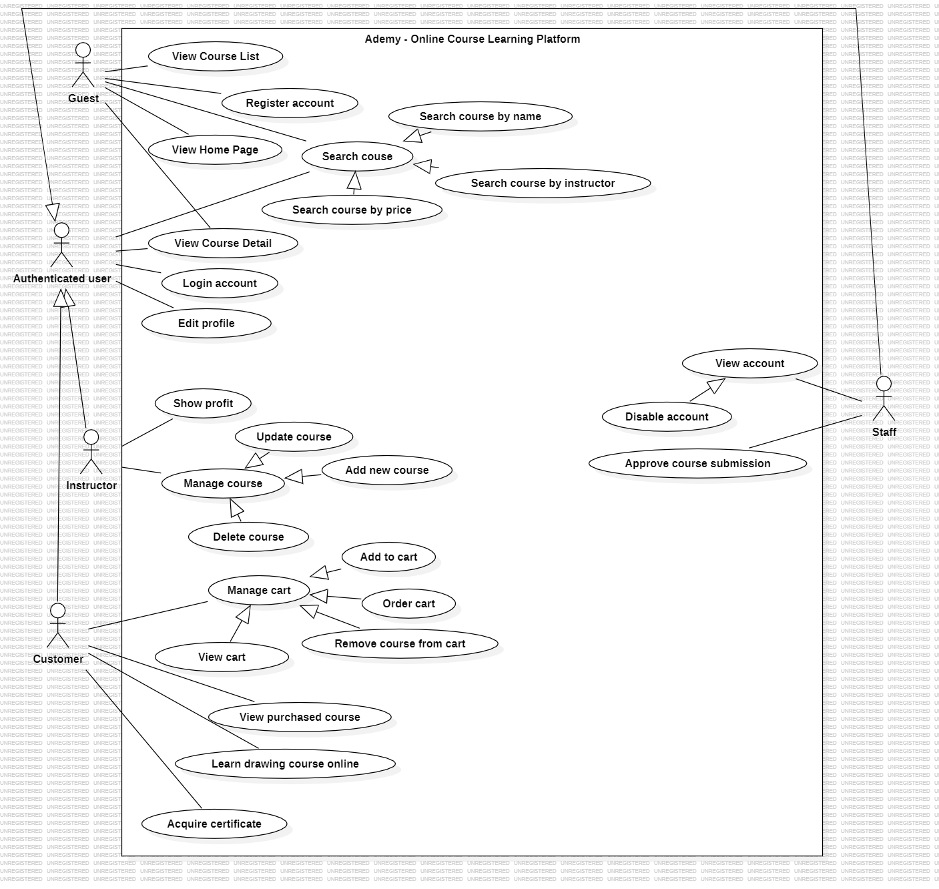

#### b. Descriptions

| **ID** | **Feature** | **Use Case** | **Use Case Description** |
| --- | --- | --- | --- |
| 01 | Authentication | Logout | Allows users to log out of their accounts, ending their session and ensuring security. |
| 02 | Authentication | Edit profile | Permits users to modify their profile information, such as name, email, or profile picture. |
| 03 | Manage Account | View account | Enables users to view their account information, including profile details and settings. |
| 04 | Manage Account | Disable account | Provides the capability to deactivate or disable a user account temporarily or permanently. |
| 05 | Manage Course | Add course | Allows authorized users to create and add new courses to the system. |
| 06 | Manage Course | Edit course | Permits authorized users to update and modify the details of existing courses. |
| 07 | Manage Course | Delete course | Allows authorized users to remove or delete courses from the system. |
| 08 | Home Page | View course list | Displays a list of available courses on the home page for users to browse. |
| 09 | System | Login | Provides users with the ability to log in to the system using their credentials. |
| 10 | System | Register | Allows new users to create accounts and register on the system. |
| 11 | System | Forgot password | Provides a way for users to reset their password if they have forgotten it. |
| 12 | Home Page | Search course | Enables users to search for specific courses by certain criteria on the home page. |
| 13 | System | Login with Google account | Allows users to log in to the system using their Google accounts for authentication. |
| 14 | Home Page | Search course by instructor name | Permits users to search for courses based on the name of the instructor. |
| 15 | Manage Course | Rating course | Allows users to rate or provide feedback on courses they have taken. |
| 16 | Manage Course | Report course | Enables users to report issues or concerns related to a course. |
| 17 | Manage Course | Comment course | Allows users to leave comments and reviews on courses. |
| 18 | Checkout | Paying by paypal | Provides the functionality to pay for courses using PayPal as the payment method. |
| 19 | System | Sending OTP through gmail | Sends a one-time password (OTP) through Gmail for user authentication or verification. |
| 20 | Home page | Search course by price | Allows users to search for courses based on their price or pricing range. |
| 21 | Home page | Search course by course name | Permits users to search for courses using specific keywords in the course name. |
| 22 | Manage cart | View Cart history | Enables users to view the history of items added to their shopping cart. |
| 23 | System | Reset password | Allows users to reset their password if they need to change it for security reasons. |
| 24 | Manage Course | Browse course | Permits users to browse through the available courses and their details. |
| 25 | Manage Course | Delete course | Provides the capability to delete or remove courses from the system. |
| 26 | Manage setting | Add setting | Allows authorized users to add new settings or configurations to the system. |
| 27 | Manage setting | Update setting | Permits authorized users to update or modify existing system settings. |
| 28 | Order course | Add cart | Allows users to add courses to their shopping cart for future purchase. |
| 29 | Order course | Remove cart | Provides the capability to remove courses from the shopping cart. |
| 30 | Order course | Payment | Handles the process of making payments for courses in the shopping cart. |

## 2. Overall Functionalities

### 2.1 Screens Flow

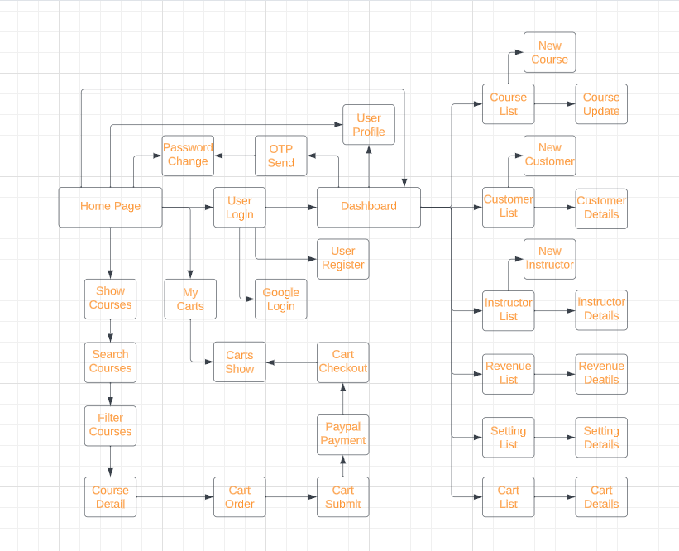

### 2.2 Screen Descriptions

| **#** | **Feature** | **Screen** | **Description** |
| --- | --- | --- | --- |
| 1 | Manage Cart | Add to cart | This action allows users to add items or products to their shopping cart in an e-commerce platform, making it easy to keep track of selected items for potential purchase. |
| 2 | Manage Cart | Remove cart | This action allows users to remove items or products from their shopping cart, typically when they decide not to purchase certain items. |
| 3 | Manage Cart | Cart details | This feature provides a summary of the items in a user's shopping cart, displaying product names, prices, and other relevant information. |
| 4 | Manage Cart | Cart Checkout | The cart checkout process involves the user finalizing their order by providing shipping and payment information, then confirming the purchase of the items in their cart. |
| 5 | Manage Cart | Cart Show | This option typically displays the current contents of the shopping cart, allowing users to review their selected items and make necessary adjustments. |
| 6 | Manage Cart | Cart Order | After reviewing and confirming the items in the cart, the user can proceed to place an order for the selected products. |
| 7 | Manage Cart | Cart Submit | This function allows users to submit their cart with the selected items, initiating the order and payment process. |
| 8 | Manage Cart | Paypal Payment | Use for paying items in their shopping carts. |
| 9 | Manage Account | Instructor details | Information about an instructor or teacher, including their name, contact information, and qualifications, often relevant in an educational or training context. |
| 11 | Manage Account | Disable account | User can disable account for a temporary time |
| 12 | Manage Account | Customer details | Customer details encompass information about individual users or clients, often including contact information, purchase history, and other relevant data. |
| 13 | Manage course | Edit course | Enables instructors to modify the content, details, or settings of a course |
| 14 | Manage course | Add course | Adding a course typically involves creating a new course, providing course content, descriptions, and other relevant information. |
| 15 | Manage course | Delete course | Deleting a course involves permanently removing a course, including all associated data and content. |
| 16 | Manage course | Show course | Show created course on instructor that have been created before |
| 17 | Manage course | Search course | Users can use this feature to search for specific courses based on keywords or criteria. |
| 18 | Manage course | Filter course | This function allows users to narrow down their course search by applying specific filters or criteria, such as subject, level, or instructor. |
| 19 | Manage course | Course Detail | This typically provides detailed information about a specific course, including its content, author, and price. |
| 20 | Manage course | Coure Update | This action enables instructors to make updates or changes to the content or details of a course |
| 21 | Login system | Password change | Users can use this function to change their account password for security reasons. |
| 22 | Login system | Send OTP | User can request OTP for password change |
| 24 | Login system | User Login | Users can access their accounts by providing their registered username or email and password. |
| 25 | Login system | User Register | New users can create an account by providing necessary information and credentials to register. |
| 26 | Authentication | Edit Profile | This feature allows users to modify and update their profile information, such as name, profile picture, and contact details |
| 27 | Authentication | Logout | Logging out terminates a user's current session, ensuring the security of their account and data |
| 28 | Authentication | User Profile | User profiles typically display information about a user, including their name, profile picture, and any additional details they have provided. |
| 29 | Manage revenue | Revenue details | This feature presents information about the financial performance of a business or platform, including income, expenses, and profit for an instructor. |

### 2.3 Screen Authorization

| **Screen** | **Guest** | **Customer** | **Instructor** | **Staff** |
| --- | --- | --- | --- | --- |
| User login |  | X | X | X |
| User register |  | X | X |  |
| Home page | X | X | X | X |
| Google login | X |  |  |  |
| Show courses | X | X |  |  |
| Search Courses | X | X |  |  |
| Filter Courses | X | X |  |  |
| Course Detail |  |  | X | X |
| Cart Order |  | X | X |  |
| Cart Submit |  | X | X |  |
| Paypal Payment |  | X | X |  |
| Cart Checkout |  | X | X |  |
| Cart Show |  | X | X |  |
| User profile |  | X | X | X |
| OTP Send |  | X | X |  |
| Password Change |  | X | X |  |
| Manage Course |  |  | X |  |
| Manage Customer |  |  |  | X |
| Manage Instructor |  |  |  | X |
| Manage Revenue |  |  |  | X |
| Manage Setting | X | X | X | X |
| Manage Cart |  | X | X |  |

### 2.4 Non-UI Functions

| **#** | **Feature** | **System Function** | **Description** |
| --- | --- | --- | --- |
| 1 | Certificate | Acquire certificate | Allows users to obtain certificates upon completing courses or certain requirements. |
| 2 | Authentication | User Customer | Provides authentication functionality for customers or users who access the system. |
| 3 | Authentication | User Instructor | Provides authentication functionality for instructors or educators who access the system. |
| 4 | Authentication | User Staff | Provides authentication functionality for staff members or administrators who access the system. |
| 5 | Authorization | User Customer | Manages authorization for customers, defining what actions they are allowed to perform within the system. |
| 6 | Authorization | User Instructor | Manages authorization for instructors, defining their permissions and actions within the system. |
| 7 | API Integration | Exchange data | Enables the system to integrate with external services or applications by exchanging data through APIs. |
| 8 | Security | Encrypting sensitive data | Implements encryption techniques to secure sensitive data, such as user credentials, payment information, or other confidential information. |
| 9 | Error Handling | Record Error | Captures and records errors or exceptions that occur within the system for troubleshooting and analysis. |
| 10 | Data Validation | Check Email | Performs validation checks on email addresses to ensure they meet the required format and are valid. |

## 3. System High Level Design

### 3.1 Database Design

#### a. Database Schema

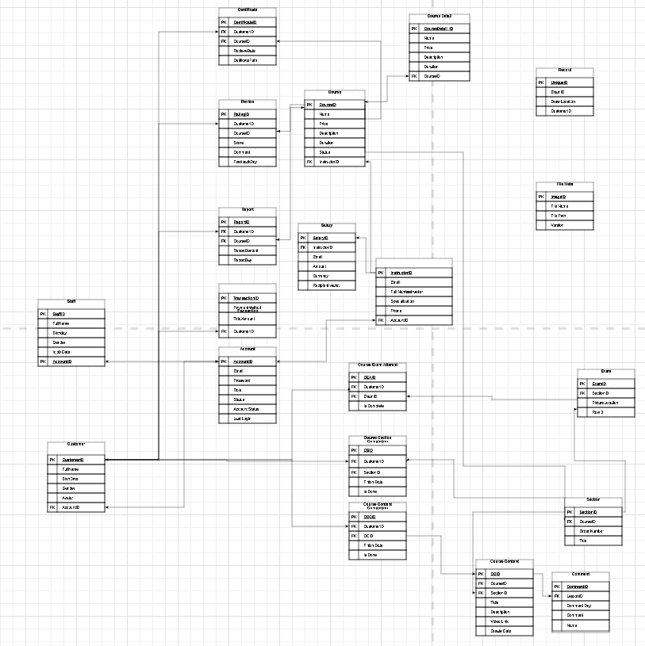

#### b. Table Descriptions

| **No** | **Table** | **Description** |
| --- | --- | --- |
| *01* | *Staff* | *PK: StaffID*  *FK: AccountID* |
| *02* | *Customer* | *PK: CustomerID*  *FK: AccountID* |
| *03* | *Centificate* | *PK: CentificateID*  *FK: CustomerID*  *FK: CourseID* |
| *04* | *Review* | *PK: RatingID*  *FK: CustomerID*  *FK: CourseID* |
| *05* | *Report* | *PK: ReportID*  *FK: CustomerID*  *FK: CourseID* |
| *06* | *Transaction* | *PK: TransactionID*  *FK: CustomerID* |
| *07* | *Account* | *PK: AccountID* |
| *08* | *Course* | *PK: CourseID*  *FK: InstructorID* |
| *09* | *Salary* | *PK: SalaryID*  *FK: AccountID* |
| *10* | *Instructor* | *PK: InstructorID*  *FK: AccountID* |
| *11* | *Course Exam Attempt* | *PK: CEAID*  *FK: CustomerID*  *FK: ExamID* |
| *12* | *Course Section Completion* | *PK: CSID*  *FK: CustomerID*  *FK: SectionID* |
| *13* | *Course Content Completion* | *PK: CCCID*  *FK: CustomerID*  *FK: CCID* |
| *14* | *Course Detail* | *PK: CourseDetailID*  *FK: CourseID* |
| *15* | *Record* | *PK: UniqueID*  *FK: CustomerID* |
| *16* | *File Meta* | *PK: ImageID* |
| *17* | *Section* | *PK: SectionID*  *FK: CourseID* |
| *18* | *Course Content* | *PK: CCID*  *FK: CourseID*  *FK: SectionID* |
| *19* | *Comment* | *PK: CommentID*  *FK: LessonID* |
| *20* | *Lesson* | *PK: LessonID* |
| *21* | *Exam* | *PK: ExamID*  *FK: SectionID* |

### 3.2 Code Packages

***Package descriptions***

| **No** | **Package** | **Description** |
| --- | --- | --- |
| *01* | ***config*** |  |
| *02* | ***controller*** |  |
| *03* | ***controller.exception*** |  |
| *04* | ***exception*** |  |
| *05* | ***dto*** |  |
| *06* | ***entity*** |  |
| *07* | ***enums*** |  |
| *08* | ***repository*** |  |
| *09* | ***service*** |  |
| *10* | ***util*** |  |

# II. Requirement Specifications

# 1. Common Functions

#### a. Functional Description

| UC ID and Name: | **UC-1_Login System** | | |
| --- | --- | --- | --- |
| Created By: |  | Date Created: | 17/10/2023 |
| Primary Actor: | Customer | Secondary Actors: | None |
| Trigger: | User clicks Login button from the page header, or  User accesses an authenticated feature (from a link or type the page URL directly into the address bar) | | |
| Description: | As a user, I want to be able to log into the system so that I can use the system’s authenticated features and access my personalized account. | | |
| Preconditions: | User account has been created & authorized | | |
| Postconditions: | * User logs in the system successfully * The system tracked successful login into the Activity Log | | |
| Normal Flow | **Login System**  1. User accesses the User Login screen  2. User types in the login details or choo other login options  3. User clicks the Login button  4. System validates the login details  5. System allows user to access  6. System tracks user’s success login to the Activity Log  7. System accesses the Home Page (or the previous calling page if any) | | |
| Alternative Flows: | ***Google Login***  1. User chooses to login system using Google account  2. System redirects the user to the Google’s Login screen  3. User types in the Google account details and chooses to login  4. Google validates user’s login information successfully and redirect him/her back to the system  5. Return to step 5 of normal flow. | | |
| Exceptions: |  | | |
| Priority: | Must Have | | |
| Frequency of Use: |  | | |
| Business Rules: |  | | |
| Other Information: |  | | |
| Assumptions: |  | | |

#### 

| UC ID and Name: | **UC-2_Register System** | | |
| --- | --- | --- | --- |
| Created By: |  | Date Created: | 17/10/2023 |
| Primary Actor: | Customer | Secondary Actors: | None |
| Trigger: | User clicks Register button from the page header, or  User accesses an authenticated feature (from a link or type the page URL directly into the address bar) | | |
| Description: | It plays a vital role in providing personalized experiences, securing user data, and allowing for controlled access to the system's features and content. | | |
| Preconditions: | - The user must provide valid registration information, including a unique username, a valid email address, and a secure password.  - The registration system should not already have a user with the same username or email address. | | |
| Postconditions: | - After registration, the user should be automatically logged in or prompted to log in.  - If the registration fails for any reason, the user should receive appropriate feedback. | | |
| Normal Flow | **Register System**  1. The user clicks on the "Register" or "Sign Up" button on the website or application.  2. The registration form is displayed, and the user provides their registration information, which typically includes a username, email address, password, and possibly additional personal details.  3. The system performs input validation to ensure that the data provided is accurate, secure, and conforms to specified criteria (e.g., valid email format, strong password requirements).  4. The system checks if the provided username and email address are unique and not already associated with existing accounts. | | |
| Alternative Flows: | 1. If the user provides invalid or incomplete data during registration, the system should display clear error messages and prompt the user to correct the issues.  2. If the system detects that the username or email address provided is already in use, it should inform the user and ask them to choose different credentials.  3. Some systems may provide a "Forgot Password" link in case the user forgets their password during or after registration. This is often part of the alternative flow for password-related issues.  4. Users may request to deactivate or delete their accounts. In this case, the system should provide the necessary steps for account deactivation or deletion, adhering to legal requirements. | | |
| Exceptions: |  | | |
| Priority: | Must Have | | |
| Frequency of Use: |  | | |
| Business Rules: |  | | |
| Other Information: |  | | |
| Assumptions: |  | | |

| UC ID and Name: | **UC-3_View Course List** | | |
| --- | --- | --- | --- |
| Created By: |  | Date Created: | 17-10-2023 |
| Primary Actor: |  | Secondary Actors: |  |
| Trigger: | After a user logs into the application, they may be directed to a dashboard or homepage where they can view a list of available courses. The act of logging in serves as a trigger to view the course list. | | |
| Description: | Users can use this feature to explore and select courses they want to enroll in, get more information about specific courses, or review their current course schedule. | | |
| Preconditions: | - To access the course list, the user must be authenticated, meaning they should have a valid user account and be logged into the application.  - Users should have the necessary permissions to view the course list. For instance, students should be able to view courses they can enrol in, while instructors or administrators might have access to different course lists with additional features. | | |
| Postconditions: | - Each course in the list should include relevant information such as the course title, description, instructor, schedule, and any other essential details.  - Users should be able to see and access enrollment or registration options for each course, such as an "Enrol" button or link.  - Depending on the application's design, users might have the ability to search for specific courses or apply filters to refine the course list based on criteria like subject, level, or date. | | |
| Normal Flow: | 1. The user logs into the application using their credentials (username and password) or other authentication methods (e.g., single sign-on).  2. After a successful login, the user is directed to their dashboard or home page.  3. On the dashboard or within the user interface, the user locates and clicks on a link, button, or menu option labeled "View Course List" or similar.  4. The system retrieves and displays a list of available courses based on the user's role and permissions. | | |
| Alternative Flows: | 1. In cases where no courses are available to the user, the system should inform the user that there are no courses to display and may suggest relevant actions, such as contacting an administrator or exploring other features.  2. If there are errors in searching or filtering the course list, the system should provide clear error messages and guide the user on how to resolve the issue.  3. If the application's servers or databases are temporarily unavailable, the system should display an error message, informing the user of the issue and suggesting they try again later. | | |
| Exceptions: |  | | |
| Priority: | Should Have | | |
| Frequency of Use: |  | | |
| Business Rules: |  | | |
| Other Information: |  | | |
| Assumptions: |  | | |

| UC ID and Name: | **UC4_Forgot Password** | | |
| --- | --- | --- | --- |
| Created By: |  | Date Created: | 17-10-2023 |
| Primary Actor: |  | Secondary Actors: |  |
| Trigger: | When a user has forgotten their password or is unable to log into their account due to a lost or compromised password. This is usually initiated by the user clicking on a "Forgot Password" or "Reset Password" link or button on the login page. | | |
| Description: | The "Forgot Password" feature is a functionality within an application, website, or system that allows users to reset their forgotten or lost passwords. This feature is essential for user account security and access recovery. It typically involves a series of steps to verify the user's identity and enable them to create a new password. | | |
| Preconditions: | - The user must have an existing account within the application for which they need to reset the password.  - The "Forgot Password" feature must be accessible to the user. This typically means that there is a "Forgot Password" link or button on the login page, and the user can access it without any issues.  - The user must provide a valid email address or username associated with their account to initiate the password reset process. | | |
| Postconditions: | - If email verification is used, the system sends an email with a unique verification link to the user's registered email address.  - The user receives the email, which contains a link to a "Reset Password" page. Clicking on this link takes the user to a secure page where they can create a new password.  - On the "Reset Password" page, the user should be able to enter a new password, typically requiring them to enter it twice to ensure accuracy.  -The user should receive a notification, typically via email or an on-screen message, confirming the successful password reset. | | |
| Normal Flow: | 1. User Initiates Password Reset  2. Provide Identity Information:  3. Identity Verification  4. Send Verification Email  5. Access Verification Email  6. Create New Password  7. Password Reset  8. Confirmation | | |
| Alternative Flows: | 1. In case the email with the verification link is not delivered or is marked as spam, the system should provide the user with options to resend the email or troubleshoot email delivery issues.  2. After a certain number of failed password reset attempts, the system may temporarily lock the user's account to prevent unauthorized access.  3. In some cases, the system may require additional identity verification steps, such as answering security questions or providing a code sent to a secondary email address or phone number. | | |
| Exceptions: |  | | |
| Priority: | Must Have | | |
| Frequency of Use: |  | | |
| Business Rules: |  | | |
| Other Information: |  | | |
| Assumptions: |  | | |

| UC ID and Name: | **UC5_Add Cart** | | |
| --- | --- | --- | --- |
| Created By: |  | Date Created: | 17-10-2023 |
| Primary Actor: |  | Secondary Actors: |  |
| Trigger: | When a user wants to include a specific item or product in their shopping cart. This is typically initiated when the user clicks on an "Add to Cart" button or icon next to the item they wish to purchase. | | |
| Description: | It allows users to select and add items to a virtual shopping cart or basket. The feature is a crucial part of the online shopping experience, enabling users to accumulate items they wish to purchase and proceed to checkout when they're ready. | | |
| Preconditions: | - The user may need to be authenticated, meaning they have a valid user account and are logged into the e-commerce platform.  - The user must have access to the product's information page or product listing where they can view details and click the "Add to Cart" button.  - The product must be available for purchase. If it's out of stock or unavailable, the "Add to Cart" button may be disabled, or a message indicating the unavailability of the product may be displayed. | | |
| Postconditions: | - After clicking the "Add to Cart" button, the selected product is added to the user's shopping cart. The cart typically displays the item name, price, quantity, and a total amount.  - The user can view the updated cart, which now includes the item they added. They can review the cart's content and continue shopping or proceed to checkout. | | |
| Normal Flow: | 1. Product Selection  2. View Product Details  3. Add to Cart  4. Product Added  5. Continue Shopping or Proceed to Checkout | | |
| Alternative Flows: | 1. If the product is out of stock at the time of adding it to the cart, the system should notify the user and prevent the product from being added. The user may be given the option to join a waitlist or receive notifications when the product is back in stock.  2. In some cases, the user might need to be prompted to log in or create an account before they can add products to their cart. The alternative flow involves the authentication process before the product is added.  3. During the shopping session, product availability may change (e.g., going out of stock). The system should update the cart to reflect these changes and notify the user.  4. In some cases, prices may change after the user adds an item to the cart (e.g., due to promotions or discounts). The system should reflect the updated price in the cart. | | |
| Exceptions: |  | | |
| Priority: | Must Have | | |
| Frequency of Use: |  | | |
| Business Rules: |  | | |
| Other Information: |  | | |
| Assumptions: |  | | |

| UC ID and Name: | **UC6_Remove Cart** | | |
| --- | --- | --- | --- |
| Created By: |  | Date Created: | 17-10-2023 |
| Primary Actor: |  | Secondary Actors: |  |
| Trigger: | When a user decides to remove an item from their shopping cart. This is typically initiated when the user clicks on a "Remove" or "Delete" button or icon associated with the item in the cart. | | |
| Description: | The "Remove from Cart" feature is a functionality in e-commerce websites and applications that allows users to remove items from their shopping cart. This feature is important for users who change their minds about a purchase or wish to adjust the contents of their cart before proceeding to checkout. | | |
| Preconditions: | - The user may need to be authenticated, meaning they have a valid user account and are logged into the e-commerce platform. Some platforms allow guest users to manage their cart as well.  - The user must have access to their shopping cart where they can view and manage the items. The cart should display the products added by the user.  - The product to be removed must exist in the user's cart. If the user attempts to remove a product that is not in the cart, the system should handle this scenario gracefully. | | |
| Postconditions: | - After clicking the "Remove" or "Delete" button associated with the product in the cart, the selected item is removed from the user's shopping cart.  - After removing the item, the user can choose to continue shopping, adding more items to the cart, or proceed to checkout when ready to complete the purchase. | | |
| Normal Flow: | 1. Access Shopping Cart  2. View Cart Contents  3. Select Item to Remove  4. Item Removed from Cart  5. Cart Icon/Indicator Update  6. Continue Shopping or Proceed to Checkout | | |
| Alternative Flows: | 1. If the user attempts to remove an item that is not in the cart or no longer exists (e.g., due to out-of-stock status), the system should handle this gracefully by providing a message indicating that the item cannot be removed or suggesting alternative actions.  2. If the user removes the last item from their cart, the system should provide a message or a visual indication that the cart is now empty and offer suggestions or links to continue shopping.  3. For users who prefer not to create an account and log in, some e-commerce platforms offer guest checkout options. The system should allow guest users to remove items from their cart. | | |
| Exceptions: |  | | |
| Priority: | Must Have | | |
| Frequency of Use: |  | | |
| Business Rules: |  | | |
| Other Information: |  | | |
| Assumptions: |  | | |

| UC ID and Name: | **U7_Add Course** | | |
| --- | --- | --- | --- |
| Created By: |  | Date Created: | 17-10-2023 |
| Primary Actor: |  | Secondary Actors: |  |
| Trigger: | When a user decides to add a specific course to their list of enrolled or selected courses. This is typically initiated when the user clicks an "Ad Course" or "Enroll" button or icon next to the course they wish to join. | | |
| Description: | The "Add Course" feature is a functionality within an educational or e-learning application that allows users to add a specific course to their list of enrolled or selected courses. This feature is commonly used in online learning platforms, allowing students to tailor their course selections to their academic or professional needs. | | |
| Preconditions: | - The user should be authenticated, meaning they have a valid user account and are logged into the educational application.  - The user must have access to detailed information about the course, including its title, description, instructor, schedule, and an "Add Course" or "Enrol" button.  - The course must be available for enrollment at the time the user attempts to add it. If the course is full or unavailable, the "Add Course" button may be disabled, or a message indicating unavailability may be displayed. | | |
| Postconditions: | - After clicking the "Add Course" or "Enrol" button, the selected course is added to the user's list of enrolled or selected courses.  - The user gains access to the course content, such as lectures, assignments, and discussions, in accordance with the course's schedule and the platform's features.  - The system may begin tracking the user's progress in the course, such as completed assignments, grades, or module completion.  - Depending on the platform's policies, the user may have the option to drop or unenroll from the course within a specified timeframe. | | |
| Normal Flow: | 1. User Accesses Course Catalog  2. View Course Details  3. Add Course  4. Course Enrollment  5. Enrollment Confirmation  6. Access to Course Content  7. Progress Tracking | | |
| Alternative Flows: | 1. If the course reaches its enrollment capacity or is no longer available, the system should display a message indicating that the course cannot be added. The user may be placed on a waitlist or informed of other courses with availability.  2. If a user's session expires due to inactivity or other reasons while adding a course, the system should prompt the user to log in again and return to the course enrollment process.  3. In some cases, users may need to go through a payment or registration process to enrol in certain courses. An alternative flow includes these additional steps before successfully adding the course.  4. If there are server or network errors during the course enrollment process, the system should provide informative error messages and the option to try again later. | | |
| Exceptions: |  | | |
| Priority: | Must Have | | |
| Frequency of Use: |  | | |
| Business Rules: |  | | |
| Other Information: |  | | |
| Assumptions: |  | | |

| UC ID and Name: | **U8_Acquire certificate** | | |
| --- | --- | --- | --- |
| Created By: |  | Date Created: | 17-10-2023 |
| Primary Actor: |  | Secondary Actors: |  |
| Trigger: | A user successfully completes a course or fulfills the necessary requirements to receive a certificate. | | |
| Description: | This use case describes the process by which a user can acquire a certificate upon successfully completing a course or meeting the necessary criteria. | | |
| Preconditions: | - The user must have enrolled in a course.  - The course must have a certification program or certificate associated with it. - The user must have completed all required course components, such as assessments, assignments, and exams.  - The user's performance and progress within the course meet the minimum criteria for certificate eligibility. | | |
| Postconditions: | - The system generates a certificate for the user.  - The certificate includes the user's name, the course name, the date of completion, and any other relevant information.  - The certificate is made available for the user to download or access.  - The user and any relevant parties, such as instructors or administrators, receive notifications of certificate issuance.  - The user can now access and download the certificate as proof of course completion. | | |
| Normal Flow: | 1. User Completes Course  2. System Validates Completion  3. Generate Certificate  4. Certificate Information  5. Certificate Availability  6. Notification  7. User Downloads Certificate | | |
| Alternative Flows: | 1. The user successfully completes all the required components of a course.  2. The system checks the user's performance and progress for certificate eligibility.  3. If the user does not meet the criteria for certificate eligibility, the system does not generate a certificate.  4. The system notifies the user that they do not qualify for a certificate due to not meeting the criteria. | | |
| Exceptions: |  | | |
| Priority: | Must have | | |
| Frequency of Use: |  | | |
| Business Rules: |  | | |
| Other Information: |  | | |
| Assumptions: |  | | |

| UC ID and Name: | **U9_Edit Course** | | |
| --- | --- | --- | --- |
| Created By: |  | Date Created: |  |
| Primary Actor: |  | Secondary Actors: |  |
| Trigger: | - User selects the "Edit Course" option for a specific course.  - Administrator or authorized user initiates the course editing process.  - A change in course details is requested by an authorized entity. | | |
| Description: | The "Edit Course" action allows authorized users to make changes to the details of a specific course within the system. This could include modifying the course title, description, schedule, instructor, location, or any other relevant information associated with the course. | | |
| Preconditions: | - User is logged into the system with appropriate permissions.  - The course to be edited must already exist in the system.  - The user initiating the edit has the necessary authorization or role to edit courses.  - Relevant course details are provided for modification. | | |
| Postconditions: | - The course details are updated in the system as per the user's modifications.  - If any changes are made to the course schedule, affected users or participants may be notified.  - The system should maintain an audit trail of the changes, including the user who made the changes and the date and time of the modifications.  - Users viewing the course details will see the updated information.  - If necessary, course-related reports, schedules, or any other associated data are updated to reflect the changes. | | |
| Normal Flow: | 1. Instructor Accesses Course  2. Edit Course Details  3. Validation  4. Save Changes | | |
| Alternative Flows: | 1. If the edited information does not pass validation (e.g., an invalid date format or an instructor not available), the system displays an error message to the user, indicating what needs to be corrected.  2. The user must correct the validation errors by adjusting the information in the form.  3. The user attempts to save the changes again after making corrections.  4. If the user chooses not to correct the errors or decides to cancel the editing process, they can choose to exit the "Edit Course" action. | | |
| Exceptions: |  | | |
| Priority: | Must Have | | |
| Frequency of Use: |  | | |
| Business Rules: |  | | |
| Other Information: |  | | |
| Assumptions: |  | | |

| UC ID and Name: | **U10_Delete Course** | | |
| --- | --- | --- | --- |
| Created By: |  | Date Created: | 17-10-2023 |
| Primary Actor: |  | Secondary Actors: |  |
| Trigger: | - An authorized user selects the "Delete Course" option for a specific course.  - An administrator or authorized user initiates the course deletion process.  - A request for course deletion is received from an authorized entity. | | |
| Description: | The "Delete Course" action allows authorized users to remove a specific course from the system. This action is irreversible and permanently removes all associated data related to the course. | | |
| Preconditions: | - The user is logged into the system with the necessary permissions.  - The course to be deleted exists in the system.  - The user initiating the deletion has the required authorization to delete courses.  - There are no dependencies or constraints that would prevent the course from being deleted (e.g., no enrolled students, ongoing sessions, or outstanding payments). | | |
| Postconditions: | - The selected course is permanently removed from the system.  - All associated data, such as course details, schedules, attendance records, and user enrollments, are deleted.  - If any users were enrolled in the course, their enrollments are terminated, and they may be notified of the course's removal. | | |
| Normal Flow: | 1. Instructor Accesses Course  2. Confirmation  3. Delete Course  4. End | | |
| Alternative Flows: | 1. If the user cancels the deletion process, the system does not delete the course. The system returns to the initial state, and no course data is removed.  2. If there are dependencies or constraints preventing course deletion, such as enrolled students or ongoing sessions, the system checks for these constraints.  3. The user may need to resolve the dependencies before being allowed to proceed with the deletion. This could involve unenrolling students, cancelling sessions, or other necessary actions. | | |
| Exceptions: |  | | |
| Priority: | Must Have | | |
| Frequency of Use: |  | | |
| Business Rules: |  | | |
| Other Information: |  | | |
| Assumptions: |  | | |

| UC ID and Name: | **U11_Search Course** | | |
| --- | --- | --- | --- |
| Created By: |  | Date Created: |  |
| Primary Actor: |  | Secondary Actors: | 17-10-2023 |
| Trigger: | The user initiates a search for a course, typically by interacting with a search bar or similar functionality on the educational institution's website or application. | | |
| Description: | The "Search Course" feature allows users to find and access information about courses offered within an educational institution's system. | | |
| Preconditions: | - The user has access to the educational institution's website or application.  - The user is logged into their account (if required) to access course-related information.  - The educational institution's course database is available and up to date. | | |
| Postconditions: | - The system presents search results based on the user's query.  - The user can view detailed information about the courses in the search results, including course names, descriptions, instructors, schedules, and any other relevant details.  - The user can further interact with the courses, such as registering, adding to their wishlist, or saving course details for later reference.  - The user can refine their search criteria or start a new search if the initial search did not yield the desired result. | | |
| Normal Flow: | 1. The user initiates a search for a course. The system processes the query but finds no matching results. The user is informed that no results were found and can refine their search criteria.  2. The user initiates a search for a course.The system encounters technical issues, such as server errors. The user is informed about the technical problem and may need to retry the search later.  3. The user initiates a search with an invalid or incomplete query.The system prompts the user to provide a valid search query.The user corrects their search query and resubmits it. | | |
| Alternative Flows: |  | | |
| Exceptions: |  | | |
| Priority: | Must Have | | |
| Frequency of Use: |  | | |
| Business Rules: |  | | |
| Other Information: |  | | |
| Assumptions: |  | | |

| UC ID and Name: | **U12_Restore Account** | | |
| --- | --- | --- | --- |
| Created By: |  | Date Created: |  |
| Primary Actor: |  | Secondary Actors: | 17-10-2023 |
| Trigger: | - The user initiates the account restoration process, typically by clicking on a "Account Recovery" link on the login page. | | |
| Description: | - The "Restore Account" feature allows users to recover access to their account in case they have forgotten their login credentials or their account has been temporarily locked. | | |
| Preconditions: | - The user must have previously created an account in the system.  - The user's account must exist in the system's database.  - The user must have valid recovery information associated with their account (e.g., email address or security questions).  - The user's account should not be permanently deactivated or deleted. | | |
| Postconditions: | - The system validates the user's request for account restoration.  - The user is prompted to provide their recovery information, such as their email address or answers to security questions.  - The user receives the recovery instructions, which may include a password reset link or a temporary access code.  - The user follows the provided instructions to regain access to their account. | | |
| Normal Flow: | 1. The user initiates account restoration by clicking on the "Account Recovery" link on the login page.  2. The system presents the user with a form or instructions to verify their identity and initiate the restoration process.  3. The user enters their recovery information, such as their email address or answers to security questions.  4. The system validates the user's input and sends a recovery email with a password reset link or a temporary access code to the user's registered email address.  5. The user checks their email, clicks on the provided link, or enters the access code.  6. The system verifies the link or access code and prompts the user to create a new password.  7. The user sets a new password for their account.  8. The system updates the account with the new password and allows the user to log in with their new credentials. | | |
| Alternative Flows: | 1. The user initiates account restoration. The user has entered valid recovery information, but the system doesn't find a registered email address associated with the provided information. The user is informed that there is no account associated with the provided recovery information.  2. The user initiates account restoration and receives a confirmation email. The user doesn't receive the email, or it is marked as spam by the email provider. The user checks their email and doesn't find the recovery email. The system provides the option to resend the recovery email or offers alternative methods for account recovery.  3. The user clicks on the password reset link or enters the temporary access code. The link or code has expired or is invalid. The user receives an error message when attempting to reset the password. The system provides the option to resend a new recovery email or generate a new access code. | | |
| Exceptions: |  | | |
| Priority: | Should Have | | |
| Frequency of Use: |  | | |
| Business Rules: |  | | |
| Other Information: |  | | |
| Assumptions: |  | | |

| UC ID and Name: | **U13_Approve course submission** | | |
| --- | --- | --- | --- |
| Created By: |  | Date Created: |  |
| Primary Actor: |  | Secondary Actors: |  |
| Trigger: | A staff receives a request to review and approve a course submission for inclusion in the system's course catalog. | | |
| Description: | This use case describes the process by which a staff reviews and approves a course submission made by an instructor or content creator for inclusion in the system's course catalog. | | |
| Preconditions: | - An instructor or content creator has submitted a course for review.  - The course submission includes all required information, such as course content, descriptions, and metadata.  - The course submission has not been reviewed or approved previously.  - The user with the role of instructor or administrator has the necessary permissions to review and approve course submissions. | | |
| Postconditions: | - If the course submission meets the system's criteria and standards, it is approved for inclusion in the course catalog.  - The approved course becomes visible and accessible to users in the system.  - The instructor or content creator who submitted the course is notified of the approval.  - If the course submission does not meet the criteria, it may be rejected or returned with feedback for revisions.  - The approval or rejection status is recorded in the system for future reference. | | |
| Normal Flow: | 1. Receive Course Submission  2. Review Course Submission  3. Approval Decision  4. Course Inclusion  5. Notification of Approval  6. End of Use Case | | |
| Alternative Flows: | 1. A staff receives a course submission request.  2. The staff reviews the course submission but identifies issues or areas that do not meet the criteria or quality standards.  3. The staff decides to reject the course submission due to identified issues.  4. The staff is notified of the rejection and feedback and is given the opportunity to revise and resubmit the course.  5. The staff reviews the revised submission.  6. If the revised submission now meets the criteria and standards, it is approved for inclusion in the course catalog. | | |
| Exceptions: |  | | |
| Priority: | Must Have | | |
| Frequency of Use: |  | | |
| Business Rules: |  | | |
| Other Information: |  | | |
| Assumptions: |  | | |

| UC ID and Name: | **U14_View purchased course** | | |
| --- | --- | --- | --- |
| Created By: |  | Date Created: |  |
| Primary Actor: |  | Secondary Actors: |  |
| Trigger: | A user, who has purchased one or more courses, wants to access and view the courses they have bought. | | |
| Description: | This use case describes the process by which a user can view the courses they have purchased within the system. | | |
| Preconditions: | - The user must have an active account and be logged in to the system.  - The user must have purchased one or more courses.  - The purchased courses must be associated with the user's account. | | |
| Postconditions: | - The user gains access to the purchased courses and can view their content.  - The system displays a list of purchased courses, and the user can select and access any of them.  - The user's progress and completion status for each course is displayed.  - Any relevant course-related actions, such as starting or resuming a course, are available to the user.  - The user can interact with and learn from the purchased courses. | | |
| Normal Flow: | 1. The user logs in to their account on the system.  2. After successfully logging in, the user navigates to the section or page where their purchased courses are listed.  3. The system displays a list of courses that the user has purchased.  4. The user selects a specific course from the list they want to view.  5. The system provides access to the selected course's content, such as lectures, materials, or assessments. | | |
| Alternative Flows: | 1. The user logs in to their account on the system.  2. After successfully logging in, the user navigates to the section or page where their purchased courses should be listed.  3. The system displays a message indicating that the user has not purchased any courses. | | |
| Exceptions: |  | | |
| Priority: |  | | |
| Frequency of Use: |  | | |
| Business Rules: |  | | |
| Other Information: |  | | |
| Assumptions: |  | | |

| UC ID and Name: | **U15_Payment** | | |
| --- | --- | --- | --- |
| Created By: |  | Date Created: |  |
| Primary Actor: |  | Secondary Actors: |  |
| Trigger: | The user initiates a payment transaction, typically by selecting a product, service, or invoice that requires payment and choosing a payment method. | | |
| Description: | The "Payment" feature enables users to make financial transactions for products or services offered within the system, facilitating secure and convenient payments. | | |
| Preconditions: | - The user must have an active account in the system.  - The user should have the necessary permissions and access to the payment functionality.  - The system's payment gateway or processor should be integrated and operational.  - The user should have a valid payment method, such as a credit card or digital wallet, linked to their account. | | |
| Postconditions: | - The system processes the payment transaction and verifies its success.  - The user receives a payment confirmation or a receipt for the completed transaction.  - The system updates relevant records, such as order history or account balances, to reflect the completed payment.  - If applicable, the user gains access to the purchased product or service. | | |
| Normal Flow: | 1. The user initiates a payment transaction by selecting a product or service to purchase and proceeding to the checkout or payment page.  2. The system displays the selected items, their prices, and the total cost.  3. The user selects their preferred payment method (e.g., credit card, PayPal, digital wallet) and provides the required payment information.  4. The system processes the payment information and initiates the transaction with the payment gateway or processor.  5. The user may need to confirm the payment.  6. The payment gateway verifies the payment and provides a confirmation to the system.  7. The user receives a payment confirmation message or receipt.  8. The system updates the user's order history, inventory, and any other relevant records to reflect the completed payment.  9. If applicable, the user gains access to the purchased product or service. | | |
| Alternative Flows: | 1. The user initiates a payment transaction. The payment gateway or processor declined the transaction due to insufficient funds, an expired card, or other reasons. The user is informed that the payment was declined and may need to provide an alternative payment method or address the issue with their financial institution.  2. The user initiates a payment transaction. The payment processing takes too long, and a timeout occurs.The user receives a message that the payment process has timed out and may need to retry the payment or check their internet connection.  3. The user initiates a payment transaction. After a successful payment, there is a need for a refund or payment reversal due to order cancellation or other reasons. The user requests a refund, and the system processes the payment reversal, which may involve refunding the money to the user's account..  4. The user initiates a payment transaction. The payment gateway or processor is temporarily unavailable. The user is informed about the unavailability of the payment gateway and may be asked to try the payment again later or use an alternative method. | | |
| Exceptions: |  | | |
| Priority: | Must Have | | |
| Frequency of Use: |  | | |
| Business Rules: |  | | |
| Other Information: |  | | |
| Assumptions: |  | | |

#### b. Business Rules

| **ID** | **Business Rule** | **Business Rule Description** |
| --- | --- | --- |
| BR1 | Invalid Logging In | User can’t be authenticated to login the system if below cases   * His/her logging-in details are incorrect * His/her account has not been verified * His/her account has been locked or blocked |
| BR2 | Account Locking | If user inputs wrong logging-in details 6 times continuously, his/her account would be locked in 30 minutes |

# III. Design Specifications

## 1. <<Feature Name>>

### 1.1 <<SubFeature Name>>

#### a. <<Screen/Function Name>>

##### UI Design

***SQL Commands***

### 1.2 System Access

#### a. CustomerLogin

This screen allows user to be authenticated to the system screens/functionalities.

Related use cases:

* [UC02_Login System](https://docs.google.com/document/d/1N9Be_5Rrja1Eqz0p28IbpcJczygAp0N5ABD9v-qy_qU/edit?fbclid=IwAR1i495xbfs6ubse4rB1mlc5Foi8JxZpEGw5D52X6wEILqGj9pT_gEChnS0#heading=h.3j2qqm3)

##### UI Design

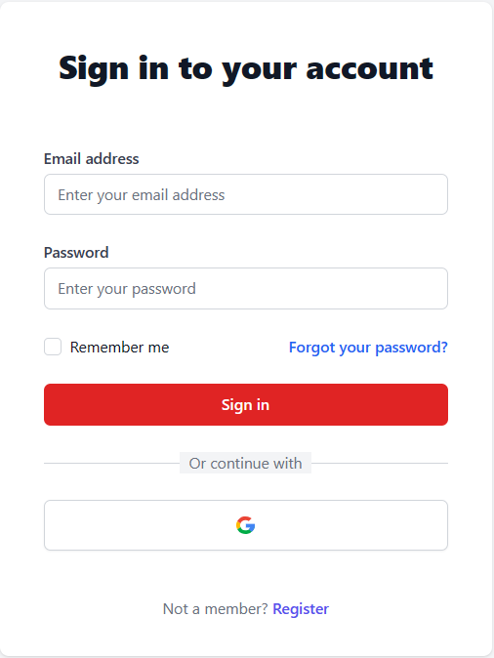

| **Field Name** | **Field Type** | **Description** |
| --- | --- | --- |
| Email* | Text Box | This is for user to input valid email address for logging in |
| Password* | Password Box | This is for user to input password for logging in |
| Login | Button | User clicks to authenticate him/herself into the system with provided email & password |
| Register | Button | User clicks to redirect to the User Register page for registering new user account to access the system |
| Remember me | Check Box | Confirm to remember customer’s email and password |
| Forgot Password? | Hyperlink | User clicks to redirect to the Password Reset page for resetting his/her forgot password |
| Login with Google | Hyperlink | Allow user to login with his/her Google account |

##### Database Access

| **Table** | **CRUD** | **Description** |
| --- | --- | --- |
| Customer | R | Verify UserName & Password information |

***SQL Commands:***

1/ Verify UserName & Password information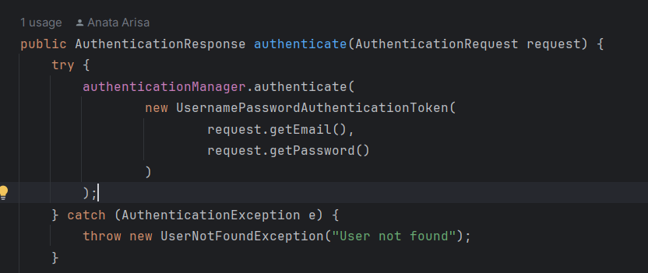

#### b. Customer Register

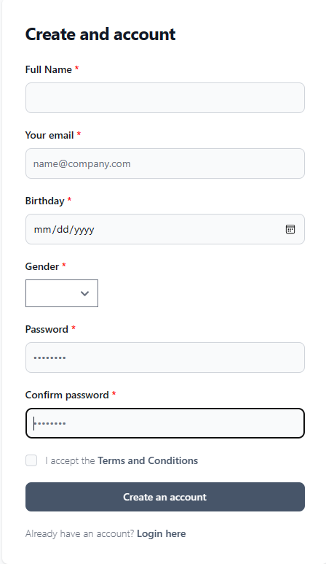

| **Field Name** | **Field Type** | **Description** |
| --- | --- | --- |
| Full Name | Text Box  String (30) | Full Name of the Customer |
| Your Email | Text Box  String (30) | Email of the Customer |
| BirthDate | Date | Birthdate of the Customer |
| Gender | Text Box  String (30) | Gender of the Customer |
| Password | Text Box  String (30) | Password of the account |
| Confirm Password | Text Box  String (30) | Refill password again to confirm |
| I accept the … | CheckBox | Confirm agree with Terms and Conditional |
| Create an account | Button | Click to create new Customer’s account |
| Login here | HyperLink | User clicks to redirect to the Customer Login page for Login customer account to access the system |

##### Database Access

| **Table** | **CRUD** | **Description** |
| --- | --- | --- |
| Guest | C | Guest create a new customer’s account to access |

***SQL Commands:***

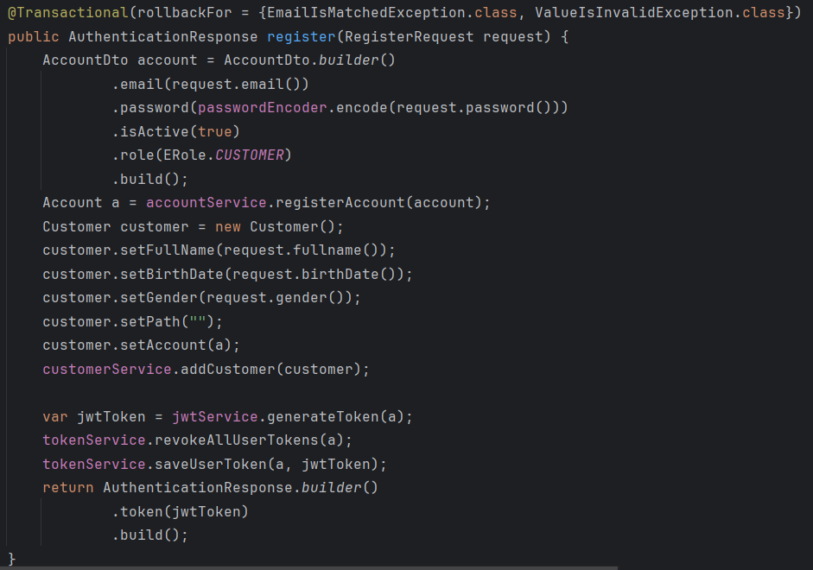

#### c. Instructor register

##### UI Design



| **Field Name** | **Field Type** | **Description** |
| --- | --- | --- |
| Full Name | Text Box  String (30) | Full Name of the Customer |
| Your Email | Text Box  String (30) | Email of the Customer |
| BirthDate | Date | Birthdate of the Customer |
| Gender | Text Box  String (30) | Gender of the Customer |
| Password | Text Box  String (30) | Password of the account |
| Confirm Password | Text Box  String (30) | Refill password again to confirm |
| I accept the … | CheckBox | Confirm agree with Terms and Conditional |
| Create an account | Button | Click to create new Customer’s account |
| Login here | Href | Click to switch to login page |

##### Database Access

##### 

| **Table** | **CRUD** | **Description** |
| --- | --- | --- |
| Guest | C | Guest create a new instructor account to access |

***SQL Commands:***

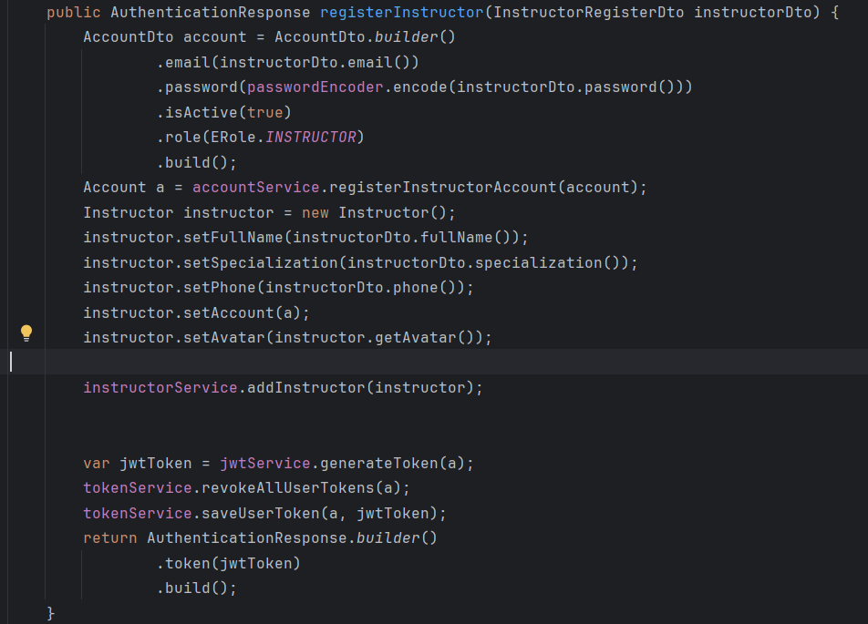

d. *Instructor login*

##### UI Design

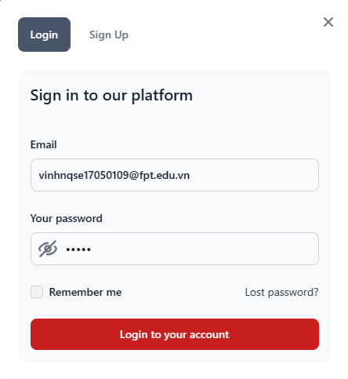

| **Field Name** | **Field Type** | **Description** |
| --- | --- | --- |
| Email* | Text Box | This is for user to input valid email address for logging in |
| Password* | Password Box | This is for user to input password for logging in |
| Login to your account | Button | User clicks to authenticate him/herself into the system with provided email & password |
| Sign Up | Button | User clicks to redirect to the Instrucer Register page for registering new user account to access the system |
| Remember me | Check Box | Confirm to remember customer’s email and password |
| Lost Password | Hyperlink | User clicks to redirect to the Password Reset page for resetting his/her forgot password |

##### Database Access

| **Table** | **CRUD** | **Description** |
| --- | --- | --- |
| Instructor | R | Verify UserName & Password information |

1/ Verify UserName & Password information

e.Search

##### UI Design



| **Field Name** | **Field Type** | **Description** |
| --- | --- | --- |
| Search | Text Box | This is for user to input keyword to find course |

f.Cart Information

##### UI Design

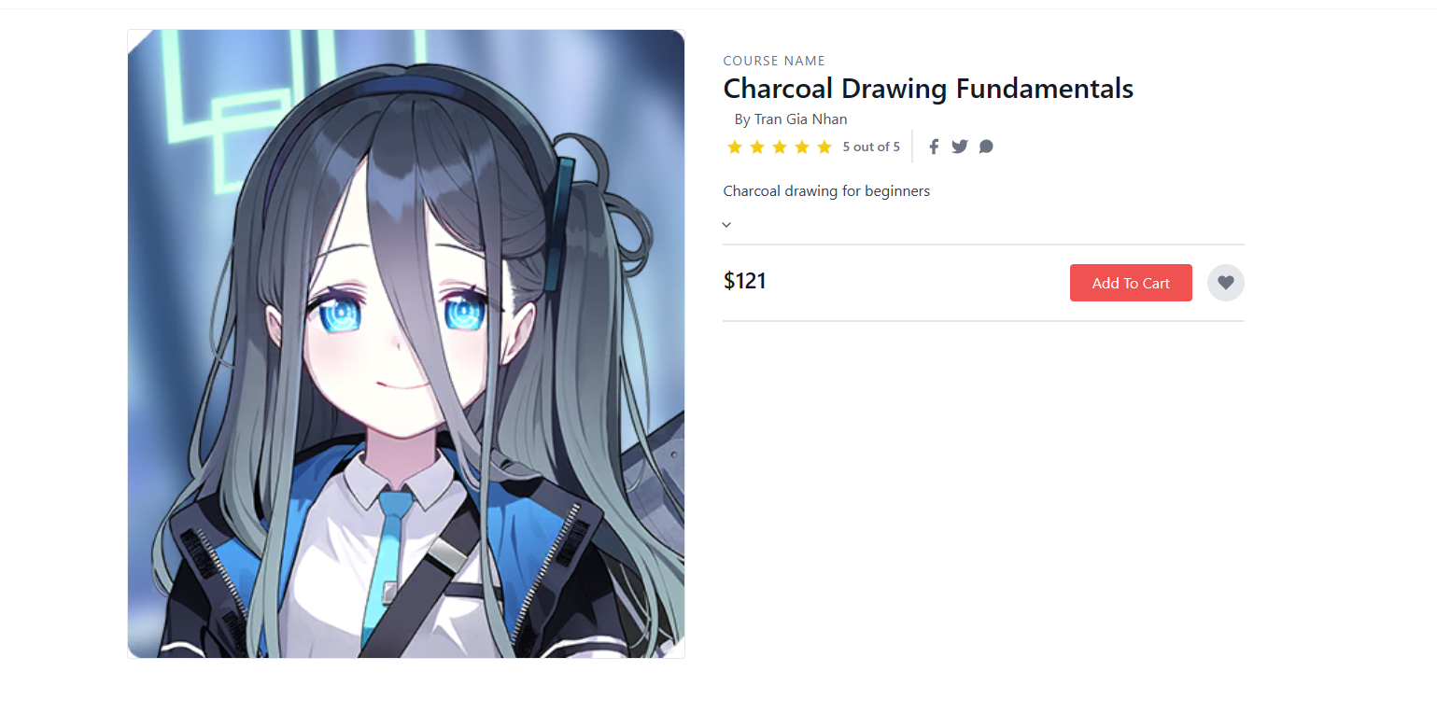

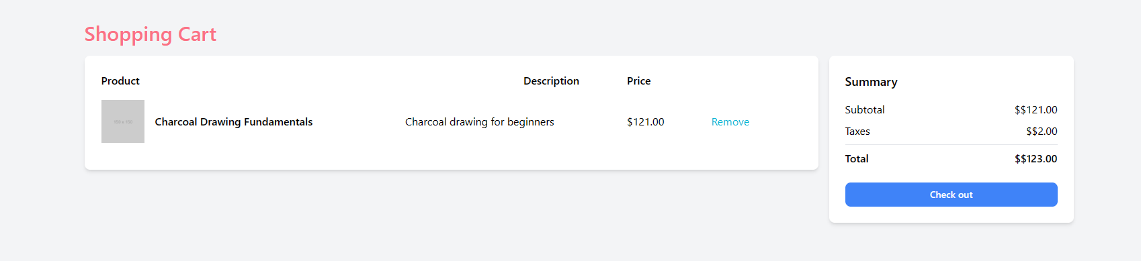

| **Field Name** | **Field Type** | **Description** |
| --- | --- | --- |
| **Course Information** | | |
| Add to Cart | Button | Customer clicks to add course to cart |
| Your Cart | HyperLink | Customer clicks to direct to the Your Cart Page |
| **Your Cart** | | |
| Remove | Button | Customer clicks to direct to the Your Cart Page |
| Total | Text  String(30) | Calculate total money of all selected course |
| Check out | Button | Customer clicks to direct to the Payment page |

##### Database Access

| **Table** | **CRUD** | **Description** |
| --- | --- | --- |
| Setting | RU | Query the list of current settings from the database  Update status of a specific setting |

***SQL Commands:***

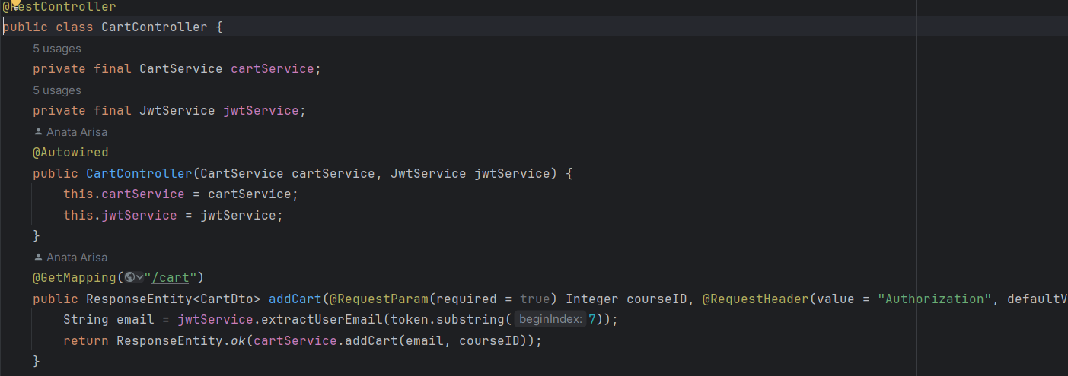

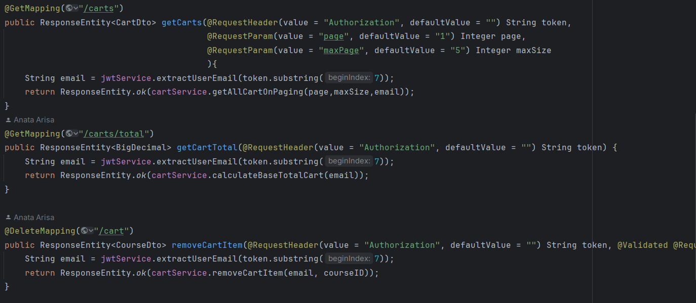

g. Course information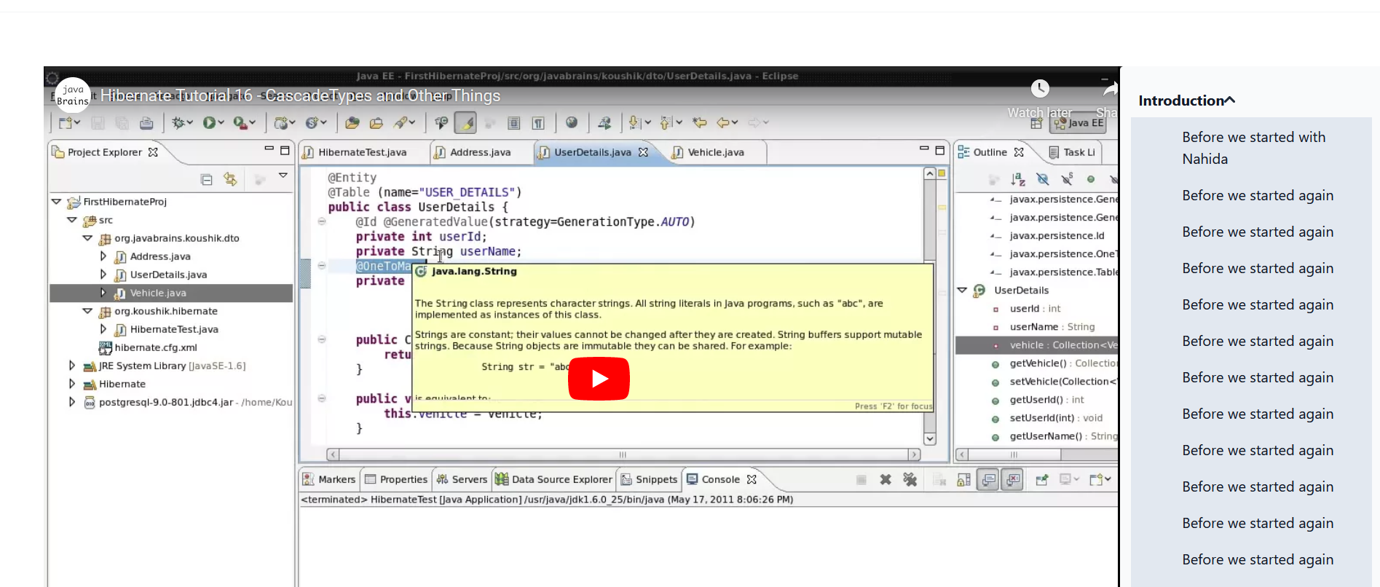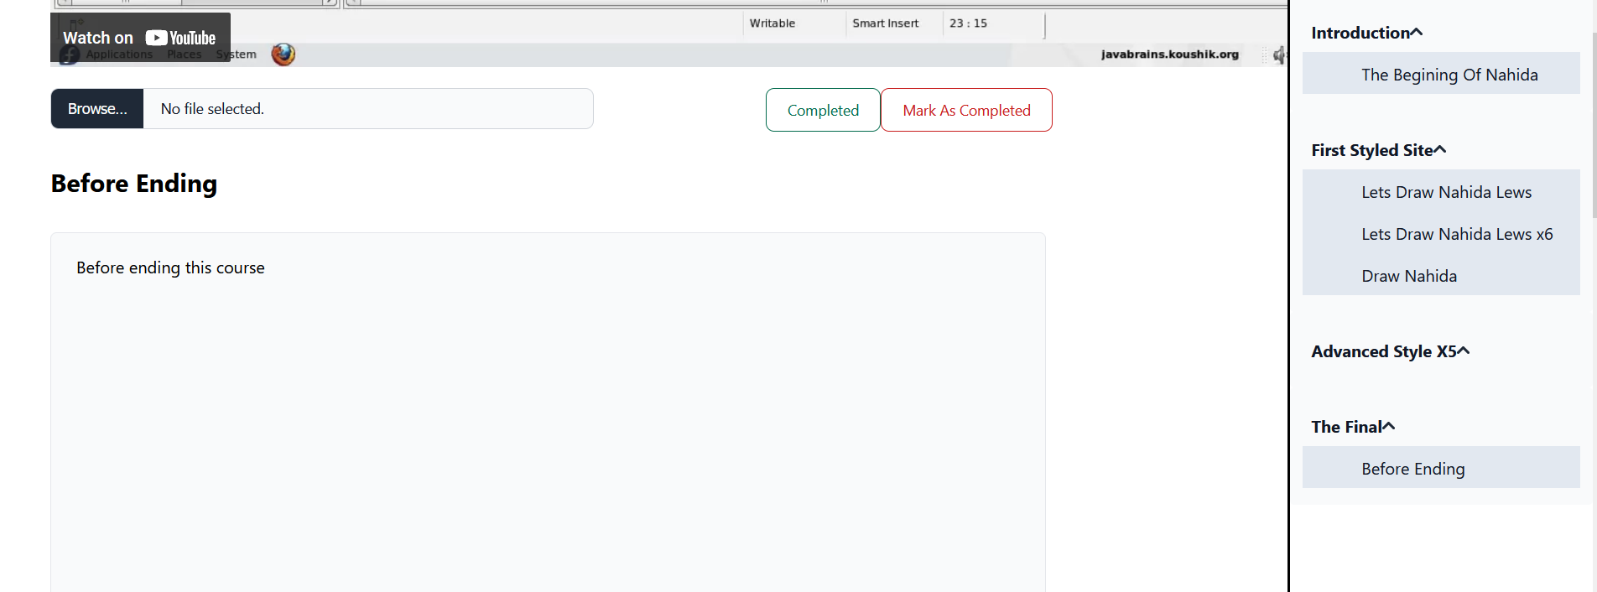

##### Database Access

| **Table** | **CRUD** | **Description** |
| --- | --- | --- |
| Customer | R | Customer access to course content |

| **Field Name** | **Field Type** | **Description** |
| --- | --- | --- |
| Mark as completed | Button | Customer clicks to confirm finishing lesson |

g. Course information

##### UI Design

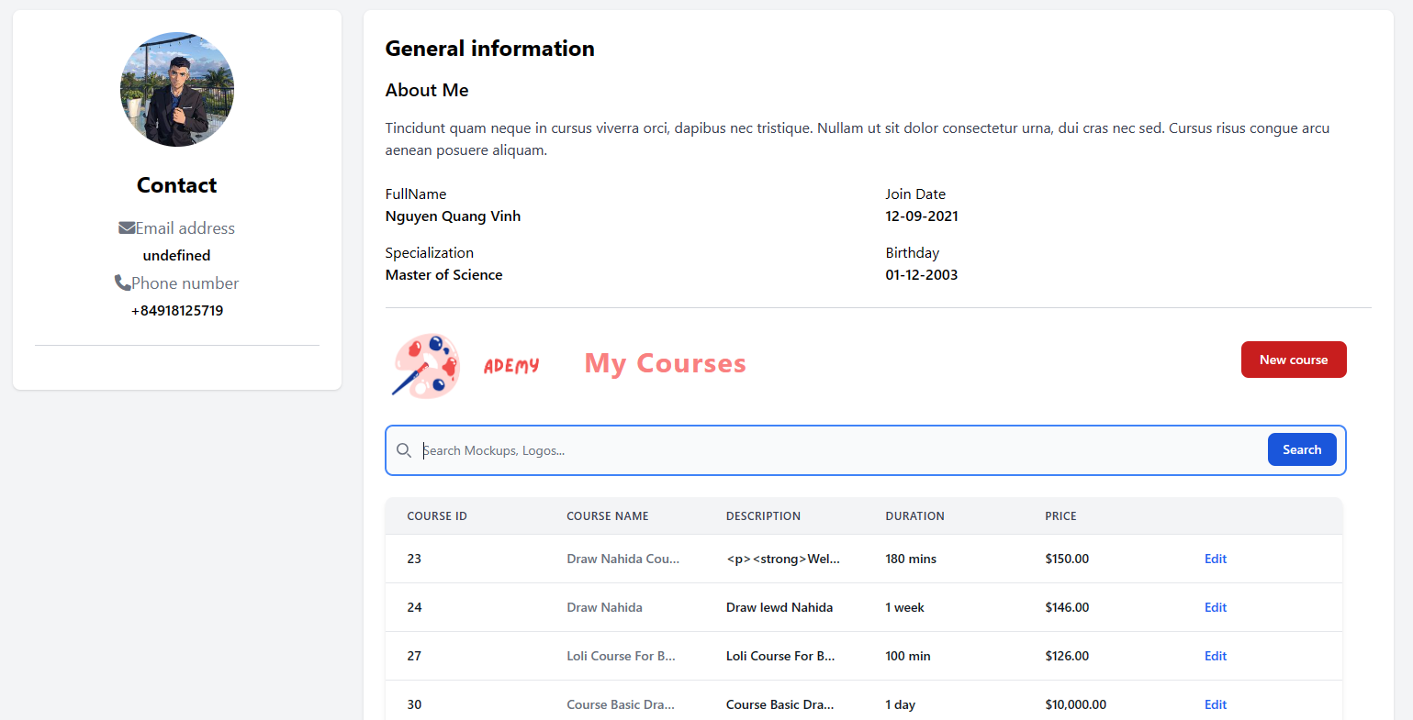

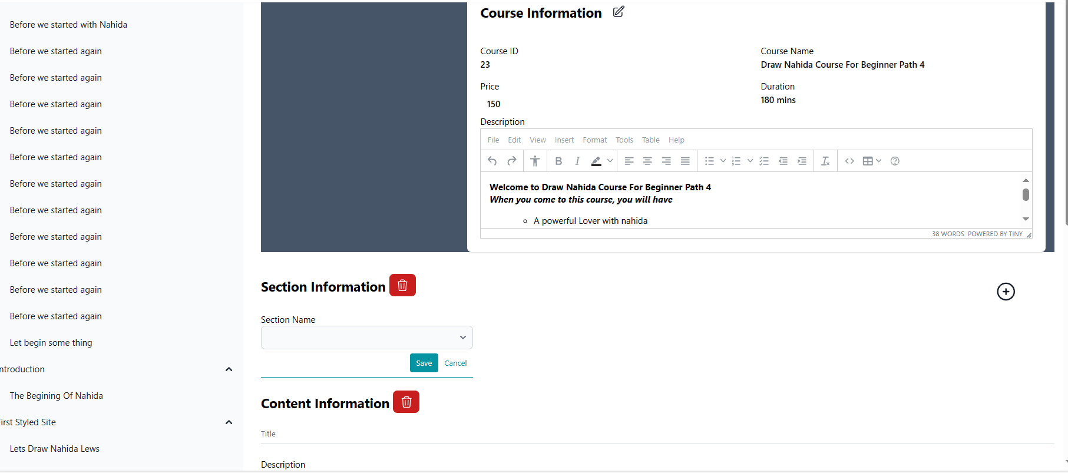

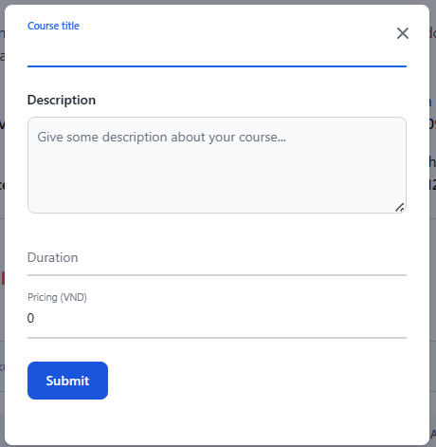

| **Field Name** | **Field Type** | **Description** |
| --- | --- | --- |
| **Course Information** | | |
| New course | Button | Instructor clicks to the New course button, automatic open a modal form to fill title,description, duration and pricing of course |
| Search | Text Box | This is for instructor to input keyword to find course |
| Edit | HyperLink | Instructor clicks to direct to Edit page for edit Section information and Content information |
| Icon | Button | Instructor clicks to transform to edit Course Id, Course Name, Price, Duration |
| Icon | Button | Instructor clicks to open a modal form to add a new section |

##### Database Access

| **Table** | **CRUD** | **Description** |
| --- | --- | --- |
| Setting | RU | Query the list of current settings from the database  Update status of a specific setting |

# IV. Appendix

## 1. Assumptions & Dependencies

<<Sample:

AS-1: Systems with appropriate user interfaces will be available for cafeteria employees to process the expected volume of meals ordered.

AS-2: Cafeteria staff and vehicles will be available to deliver all meals for specified delivery time slots within 15 minutes of the requested delivery time.

DE-1: If a restaurant has its own on-line ordering system, the Cafeteria Ordering System must be able to communicate with it bi-directionally.

>>

## 2. Limitations & Exclusions

## 3. Business Rules

| **ID** | **Category** | **Rule Definition** |
| --- | --- | --- |
| BR-01 | Constraints | Delivery time windows are 15 minutes, beginning on each quarter hour. |
| BR-02 | Constraints | Deliveries must be completed between 10:00 A.M. and 2:00 P.M. local time, inclusive. |
| BR-03 | Facts | All meals in a single order must be delivered to the same location. |
| BR-04 | Facts | All meals in a single order must be paid for by using the same payment method. |
| BR-11 | Constraints | If an order is to be delivered, the patron must pay by payroll deduction. |
| BR-12 | Computations | Order price is calculated as the sum of each food item price times the quantity of that food item ordered, plus applicable sales tax, plus a delivery charge if a meal is delivered outside the free delivery zone. |
|  |  |  |

## 4. ..

## 